**Please change the Background image**

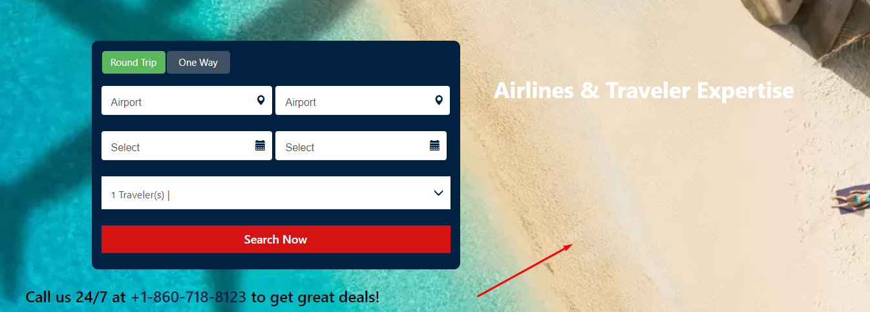

**Please fix this content on home page**

**Example site**



**Remove this content**



**Remove this part**

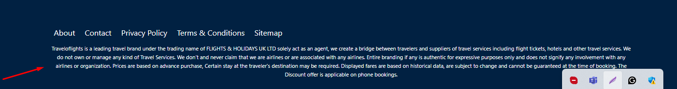

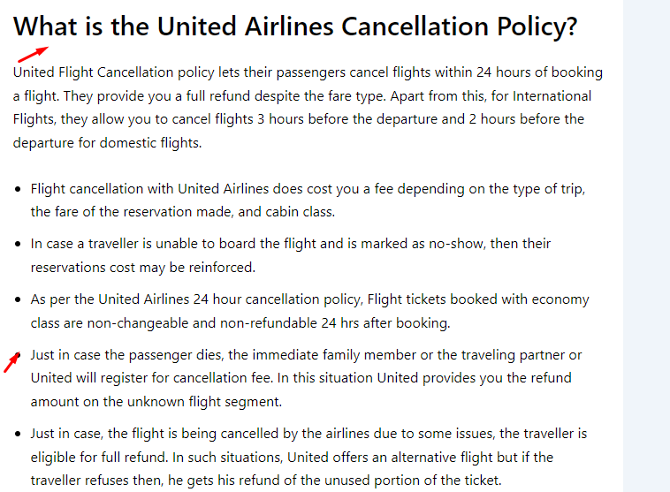

**Please use this format**

**Example**

